02 - Beatles – All My Loving
Original key: E Us: Same KORG:PICK + WURLI

[Verse] KORG:PICK or add vocal harmony
f#m | B7 | E | c#m | A | f#m | D | B7
f#m | B7 | E | c#m | A | B | E | E

[Chorus] c#m | C+ | E [2x]

[Solos]
A | A | E | E | f#m | B | E | E

[Coda]
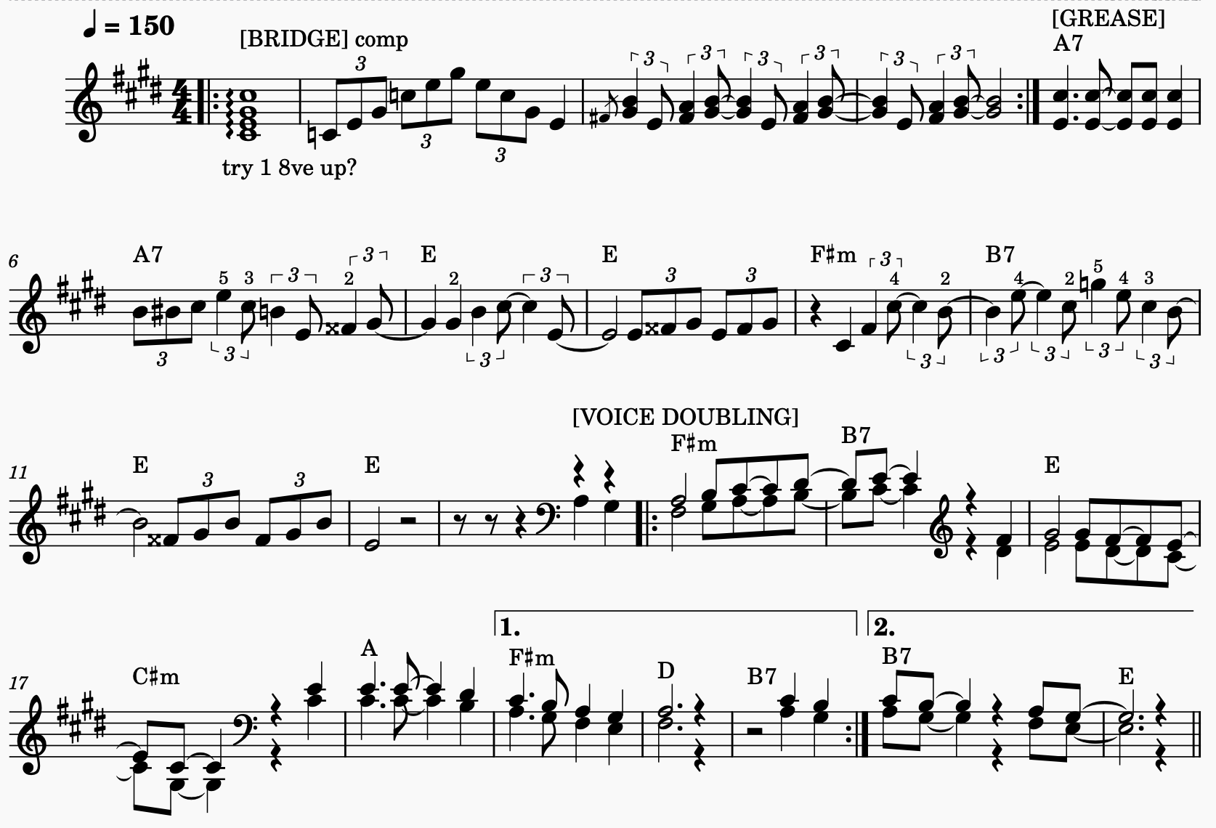
c#m | c#m | E | E

